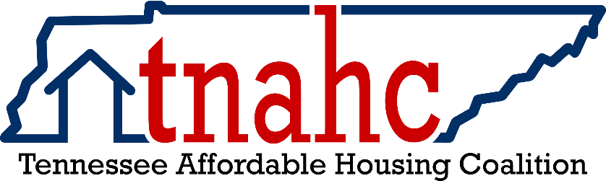

Board Meeting Minutes Draft
Friday, June 6, 2025; 10 – 12, Central
Teams: https://teams.live.com/l/invite/FAAZqiZKRlrKp_t3QQ.
Patricia Smith, Executive Director in attendance

Board Members in Attendance:

Angela Hubbard, Chair
Brian Drobnick, Vice Chair
Kevin Hicks, Treasurer
Angela Belcher, Secretary
Keith Turbett, Past President
Sharon Bosworth
Ashley Cash
Staci Coleman
Sam Edwards
Tonya Estevez
Krystal Gibbons
Angela Gentry Jackson
Jackie Mayo
Dale Mitchell
Kim Randell
Derrick Solomon
Kimberly Avon
Trey McKnight
Lindy Turner

Meeting was called to order at 10:17, a quorum was noted. All Board members in attendance had an opportunity to introduce themselves, including name, organization name, and why they are active in the coalition.

The Board reviewed the April 22, 2025 Board meeting minutes. A motion was made by Sharon Bosworth and seconded by Krystal Gibbons. All Board members voted to approve the minutes as presented.
Kevin Hicks presented the financial report, with a current bank balance of approximately $26,600, increasing from the last meeting due to new memberships. The largest monthly expense is the ED salary. Dale Mitchell, Trey McKnight, and Ashley Cash requested invoices for membership to provide to their accounting departments.
Patricia Smith provided the Membership Report, with 51 paid memberships for 2025 to date. Patricia will send invoices out to those who requested them. There were 172 website visits over the last 30 days.
Patricia Smith announced Regional Leadership for each division: East—Lindy Turner; Middle—Kimberly Avon; West—Trey McKnight.
Patricia Smith led a discussion related to a recommended change in the Bylaws:
The current and posted bylaws were last revised in December 2020. This amendment relates to the categories specified for representation on the board. Those categories are listed on page 3.
Since the last revision, the HCET, Home Counselors and Educators of Tennessee, is no longer functioning. The purpose of this bylaws amendment is to continue the presence and voice of professional housing counselors on the board, without the requirement that they be members of HCET.
As such, we recommend a change in the wording for item 8 in Section 3.2 of Article III Board of Directors.
The current wording is
8) Home Counselors and Educators of Tennessee (HCET).
The recommended wording is
8) Persons offering home ownership counseling in a professional setting that is marketed to the public, preferably HUD-certified counselors.
Angela Belcher read the proposed amendment for those who didn’t have it readily available. Jackie Mayo asked clarifying questions about the recommendation. Derrick Solomon made a motion to approve as presented, which was seconded by Trey McKnight. All members present voted to approve the change.
Patricia Smith requested that all Board Members review their Board information listed by Wednesday, June 11, and report to her it is accurate. All information will be available on the TNAHC website.
As clarification, Patricia confirmed term lengths for all Board seats:
Regional Officers—1-year term, with an option to be re-elected 2 additional times, for 3 years total.
Regional elections should be held in the fall for a January 1 effective date.
Board Members—3-year term, with an option to be re-elected 2 additional terms, for 9 years total.
Board Elections will be held at the annual TN Housing Conference. For 2026, the dates are February 23 and 24.
The following Committees exist in the bylaws: Communication, Education, Finance, and Legislative. We need a Chair and Vice-Chair for each Committee from the board. Kevin Hicks is the Chair of Finance, and Dale Mitchell volunteered to serve as Vice-Chair. Derrick Solomon volunteered to serve as Vice-Chair of the Legislative committee. The Board was encouraged to find a place to get plugged in, with a goal of having all committees formed by mid-July, 2025. Brian Drobnick, vice chair, is interested in developing a strong Sponsorship Committee.
Each region has scheduled meetings in June.
Middle TN: June 10, Mercy Healthcare, Franklin 25-50 people expected
East TN: June 16, Summit Leadership, Johnson City 30 registered to date
West TN: June 30, Wing Guru, Whitehaven/Memphis expecting 30-40 people
Meeting participants—a discussion regarding whether non-members can join the regional meetings. Attendance records need to be taken at each meeting. Lindy Turner made a motion to allow non-members to attend 2025 meetings to help boost interest, while voting would remain with paid members. Kimberly Avon seconded the motion. All board members in attendance voted to approve.

Angie Hubbard and Patricia Smith led a conversation on Board Member expectations. Member Development is key, and all board members should support activities that bring us together, provide great content, build relationships with government/industry, and provide valuable education. Several members offered suggestions to boost membership, as well as membership levels. Angela Belcher provided a summary of current levels offered. The Communication committee should focus on strategic marketing and a membership drive.

Quarterly Board meeting dates were discussed. Meetings will be held from 10-12 CT virtually, with the exceptions of the Annual meeting at the TN Housing Conference, which will be in person. The agreed upon dates are:
- September 12, 2025
- December 12, 2025
- February 22-23, 2026
- May 15, 2026
- August 21, 2026
- November 13, 2026
Trey McKnight requested that calendar invitations be sent out ASAP.
Additional items discussed during the meeting were Day on the Hill, which will need to have a date determined, as well as logistics. This will be discussed further at the September meeting. This is an important way to help build relationships with legislators. Patricia Smith also discussed the monthly newsletter, which will rely on content to be provided by Board Members. Derrick Solomon emphasized that our work is very needed and appreciates being a part of the Board. Jackie Mayo emphasized the need for a consistent statewide message, as we are stronger with a unified message. Angie Hubbard stated that we should stay updates and aware of potential federal impacts on both the state and local levels. Patricia Smith also mentioned that we should work to support THDA’s efforts.
With no further items to discuss, Keith Turbett made a motion to adjourn the meeting, seconded by Trey McKnight. All approved, and the meeting adjourned at 11:33 am.

___________________________________ ________________________________________
Secretary Angela Belcher Chair Angie Hubbard
_____________________ __________________________

